Getting A Hang of Tweepy & Building Towards SNAP

After running through upwards of 15 potential ChiPy projects over the past two weeks, vetting multiple potential data sources, I finally settled on the goal of building an app using twitter data that will feature network or sentiment analysis. In short, network analysis comes from a subset of mathematics called graph theory and is used to map relationships. In the social sciences, it is commonly used to determine the density, structure, and complexities in relationships between people in social systems.

With the help of my mentor, I managed to learn the basics of beautifulsoup, the python requests library. And finally, one morning before work, in 6 lines of code I pulled the top of my twitter timeline using tweepy, a python library for the twitter api:

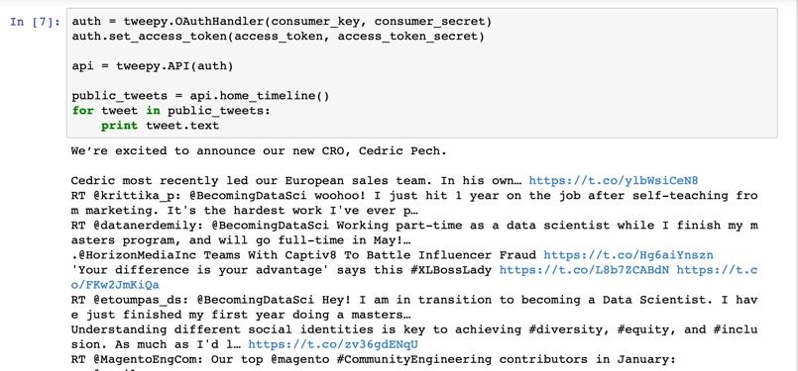

Having successfully pulled data from twitter’s api, I’ve since transitioned to figuring out how to structure my data. In order to run network analysis (specifically, [SNAP.py](http://snap.stanford.edu/snappy/index.html#about)) I need my data structured as nodes/vertices (users) and edges/connections (their relationships). For simplicity’s sake, I plan to start by building a directed visualization of my relationship to my followers using tweepy’s api.followers. This shouldn’t be terribly difficult since my follower count has dropped to 102 since my last tweet in August, here goes:

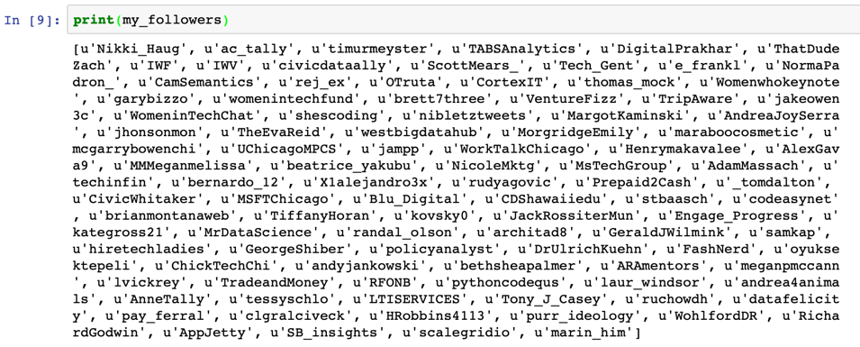

Now that I have this depressingly-short list of my twitter followers. I can work on assigning them as nodes.